Calculus 2 Lecture 10.5: Calculus of Polar Equations

Area bounded by a polar curve.

NOTES: 1. Area of a circle: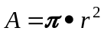
2. Area of a secto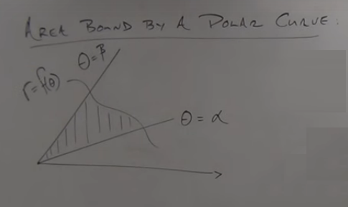r can be obtained by multiplying
the circle's area by the ratio of the angle and 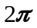
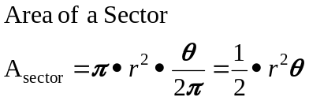

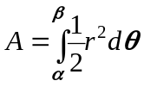
Example
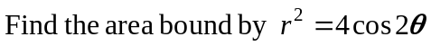
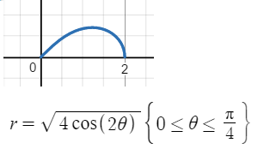
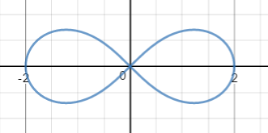
Entire graph 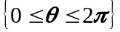

To find entire area bounded by entire curve find the area for the interval 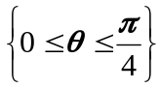 and muliply by 4 because the graph is symmetrical
about the polar and 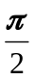 axis.

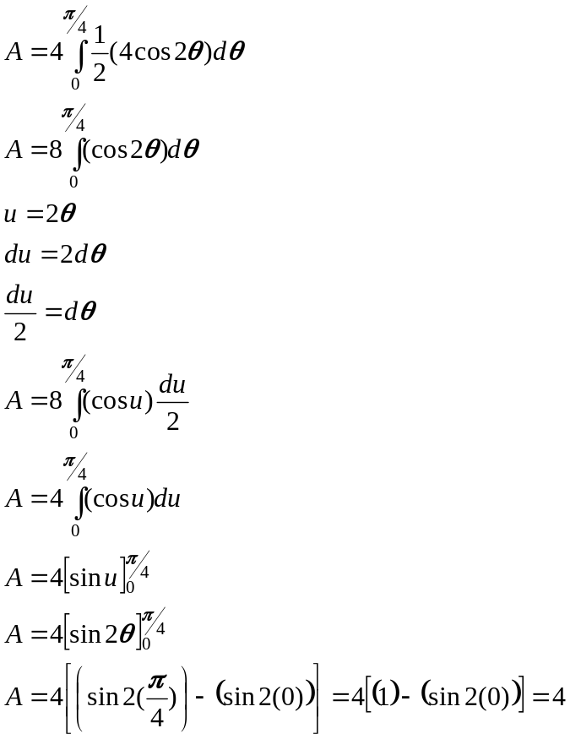

Example
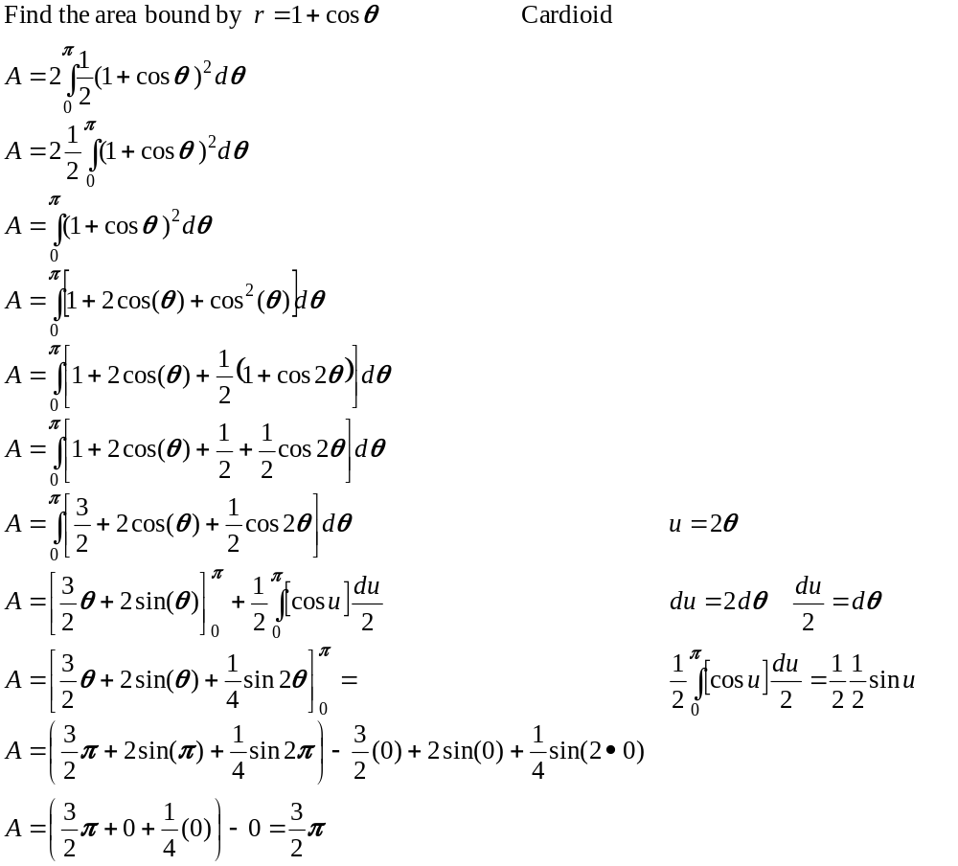
Area bounded by two polar curves
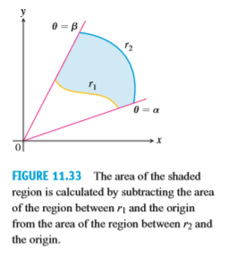
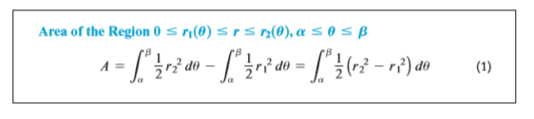

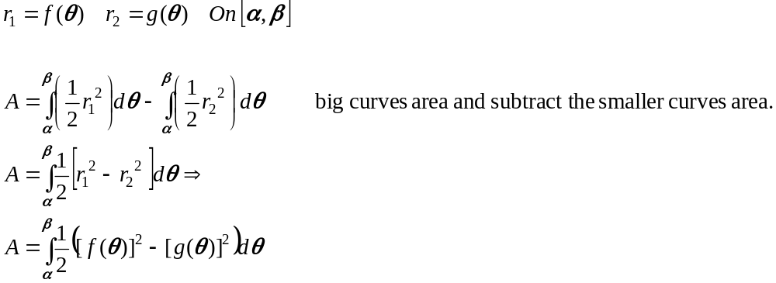

Example
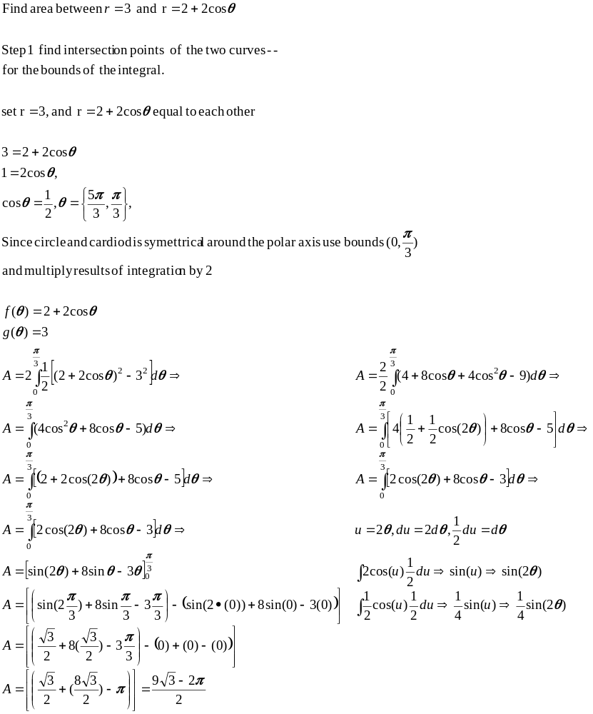

Arc Length of polar equations
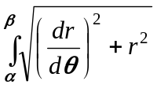

Area of a surface of revolution
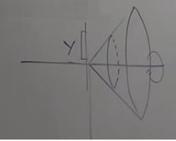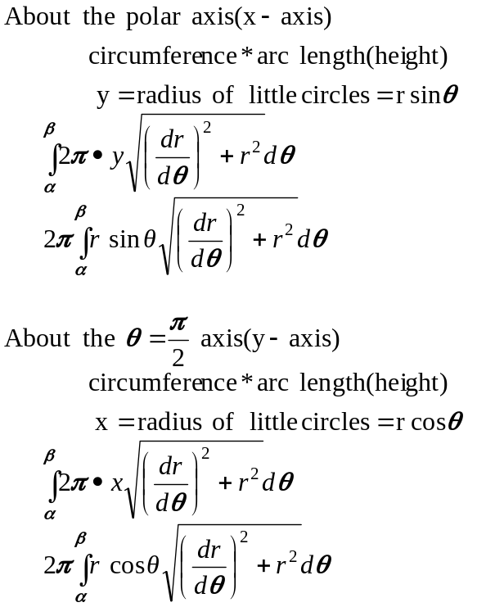

Intersection of 2 polar curves.
NOTE when polar curves intersect at the polar origin when solving for theta (angles) the equations
may not show that the curves intersect at the origin because they do not arrive at the origin at the
same time. (each curve reaching the origin at a diffent angle)

Example
